Social Thinking Terms and Teacher Tools
Social Thinking Term/Phrase | Definition | Classroom Example | Recommended Children’s Books | Unthinkable that applies | Resources or Activities
Social Thinking | Social thinking is what we do when we interact with people: we think about them. And how we think about people affects how we behave, which in turn affects how others respond to us, which in turn affects our own emotions. | Susie greets her teacher in the morning. She notices by her teacher’s face that she feels good about her actions and therefore Susie feels good about herself. | A Walk in the Rain with a Brain by Edward M. Hallowell  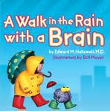 | All unthinkables can be linked to various situations | *Self-evaluation for group assignment  *Social Thinking happens everywhere  *Being part of a classroom requires social thinking
Expected Behaviors | Understanding that hidden rules exist in every situation and people are responsible for figuring out what the rules are and then following them. By doing this, we keep other people thinking good thoughts about us (blue thoughts). | I love the way that Tim comes in every morning and gets busy right away with his morning work. | No, David! By David Shannon  Hunter’s Best Friend at School by Laura Malone Elliott  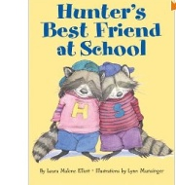  Froggy Goes to School by J. London  Blabber Mouse by True Kelley  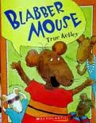  Big Bad Wolves at School by Stephen Krensky  Oh No, George by Chris Haughton  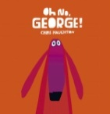  If Everybody Did it, by Jo Ann Stover  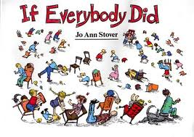  I Know, I Know, I Know by Ruth Sidney Charney | All unthinkables can be linked to various situations | *Cooperation and Competition  *People think about other people in all  *Kinds of places.
Unexpected Behaviors | Failing to follow the set of hidden rules in the environment. People who don’t follow the rules are doing what is unexpected and people may have uncomfortable thoughts about them(red thoughts). | My class continues to have trouble with transitions. They know what is expected, but they continue to talk and not following directions. |  | All unthinkables can be linked to various situations | *Solving problems before they become problems  *Learning about our own behavior, be a detective.  *Self-monitor!  *Making a behavior plan for yourself  *Monitoring sheet  *Group Rules when things go sour.  *People think about people in all kinds of places.
Flexible Thinker | Needed in order to understand verbal or non-verbal information on different points of view. This is the opposite of having a rigid brain, where one follows a rule all the time or cannot interpret different meanings in language or expression. Being a flexible thinker allows you to compromise and get along with others better. | We had to miss our recess because of the fire drill. I had several students who could not get past it and it ruined their day. | Your Fantastic Elastic Brain by JoAnn Deak  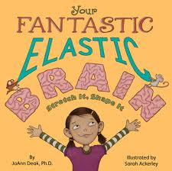 | Superflex—All of us should strive to be like superflex and defeat the unthinkables
Social Detective | We are good social detectives when we use our eyes, ears, and brains to figure out what others are planning to do next. | I see that the agenda says we are doing math next, I’m going to get out my math book and be ready. | Weiner Wolf by Jeff Crosby | All unthinkables can be linked to various situations | *Utilize the artwork of Norman Rockwell to discuss social scenes (example: No Swimming)  *Seeing other people’s plans through their body actions.
Hidden  Rules | Unspoken or unposted rules that are learned through experiences | *Holding the door for another person  *Eating with your mouth closed  *Saying please and thank you  *Saying excuse me when you walk through two people who are talking | Sorry, I forgot to Ask! By Julia Cook  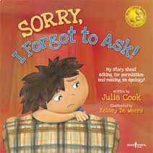  Interrupting Chicken by David Ezra Stein  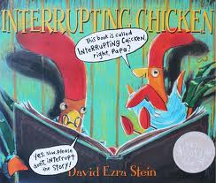  Dude That’s Rude by Pamela Espeland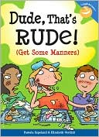  What if Everybody Did it? By Ellen Javernick  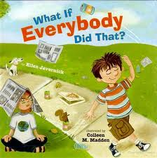 | All unthinkables can be linked to various situations | *Social Judgment
Boring Moments | We all need to participate in some boring moments. Many things we are asked to do are boring but we must have skills or thoughts to make the best of these moments. | “I’ve tried to think of flashy things to help teach history. I know it’s not exciting, but they are showing me they are bored by putting their head on their desk and not participating.” | I’m Bored by Christine Schneider  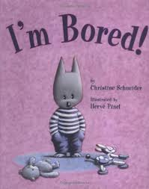  Beatrice Doesn’t Want To by Laura Numeroff  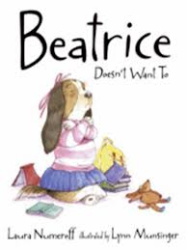 | One-Sided Sid | *The Boring Moments…we all have them.  *Boring moments, we all have them.
Whole Body Listening (Body in the Group) | - Whole Body Listening is more than just “hearing” with the ears. It includes:  - eyes (looking at the speaker)  - mouth (closed and quiet - no talking, humming, making sounds, etc.)  - body (facing the speaker)  - hands (quietly at the side of the body or in the lap)  - feet (standing still or quietly on the floor)  - brain (thinking about what the speaker is saying)  - heart (caring about what the speaker is saying) | “During my calendar time, Katie rolls around the carpet or sits backwards during my lesson.”  or  “There are students who have their backs turned to me while I’m talking. I really wish they’d square up to me so I know they are listening.” | Howard B. Wigglebottom Learns to Listen by Howard Binkow  Whole Body Listening Larry at Home and School by E. Sautter  Personal Space Camp by Julia Cook  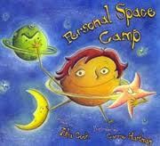  Sit Still by Nancy Carlson  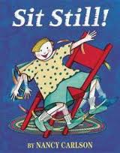  The Very Noisy Night by D. Hendry  Mrs. Gorski, I think I have the Wiggle Fidgets by Barbara Eshman  We Listen…We Don’t Interrupt by Donna Luck  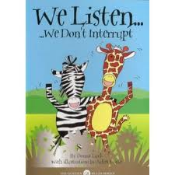  Hands Off Harry by Rosemary Wells  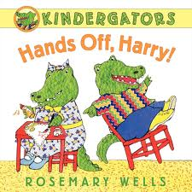 | Body Snatcher  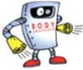  Brain Eater  Space Invader  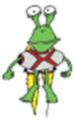 | *Behaviors for learning  *Helping to get ourselves focused  *Being with a group is a privilege.
Brain in the Group | The idea that the whole body (eyes, ears, mouth, hands, feet, and brain) needs to be focused on the group in order to listen and show you are listening. | “Johnny continually comes up and asks what to do after I’ve spend 10 minutes go over the directions.” |  |  | *Play dough activity  *Class goal for Brain in the Group
Thinking Eyes | Your eyes are tools that help you figure out your environment and what other people might be thinking about us. Also, if you use your eyes to look at a person, it makes them feel that you are thinking about what they are saying or doing. | “I have a student who blurts out answers all day long. I wish she knew when it was her turn to share.”  or  “I have a student who reads a book during my lesson every day.” |  |  | *Thinking eyes activity- “you know it is your turn to talk/ line up when you see me looking at you.”  * Transitioning activity from carpet to desk --Use your thinking eyes and when you see that a paper has been placed on your desk, you can back to your seat.  *What do eyes tell us?  *Eye contact and thinking with your eyes.
Thinking Hands | Busy hands mean you brain is out of the group; Still and calm hands show a person is paying attention | “Susie plays with everything in her desk during the day.”
Uncomfort-able Thoughts | Thoughts people have about you when you are exhibiting unexpected behaviors. | “I have a student who picks his nose constantly in class.” | Just Me and My Mom by Mercer Mayer  The Busy Beaver by Nicholas Oldman  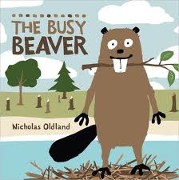  Seriously, Cinderella is SO Annoying by Trisha  Sue Speed Shaskan  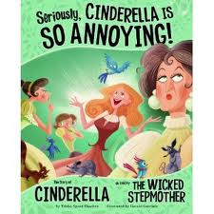  They Didn’t Use Their Heads by Jo Ann Stover  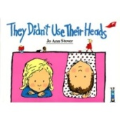 | All unthinkables can be linked to various situations | *Checking my own behavior.  *Embarrassment
Smart Guess/  Wacky Guess | Smart guesses are guesses that make sense, taking into account what knowledge we already have about the people involved, the environment, and what’s already happened. Wacky guesses are random guesses that have no logic. | “The other day, I asked the students to name a country one of my students guessed the name of a city. How do I help them make a smart guess.” | The Napping House by Audrey Wood | (In some situations…)  Was Funny Once | *Working on making smart guesses  *Making Guesses…
Friend Files | Information you store in your brain about people you meet. We can pull out this information from our brain file when we need to start a conversation or to show someone we care about them. | “I have a student who teases someone because they have problems learning how to read.” (i.e.: They are not using prior information they know about this child.) | Tico and the Golden Wings by Lio Lionni | n/a | *Once we have a friend, we keep friendly files in our heads.
Size of Problems (Big Problems/ Little Problem) | Not all problems should get the same emotional reaction. Big problems call for stronger emotions and help. Little problems are “glitches” and can be worked out if you stay flexible. | “All my students are overreacting and crying over little things that happen on the playground.” | Wilma Jean the Worry Machine by Julia Cook  When Sophie Gets Angry…really Really Angry by Molly Bang  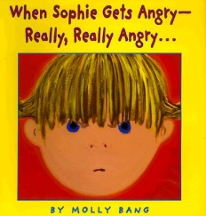  Franklin in the Dark by Burgeois  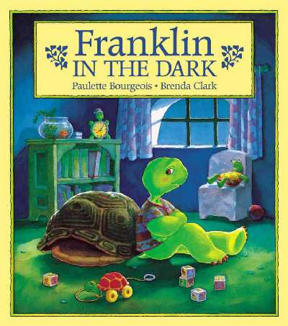  The Kissing Hand by A. Penn  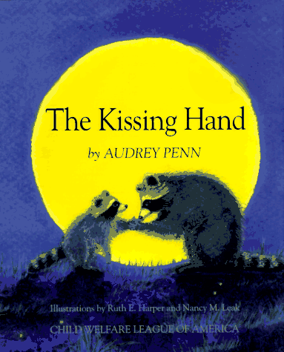  Sometimes I feel Green by Lynn Hubbel  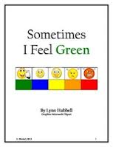  You’ve Got Dragons by Kathryn Cave  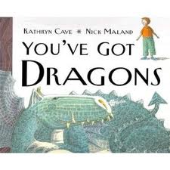  Don’t Squeal Unless it’s a Big Deal by Jeanie Franz Ransom  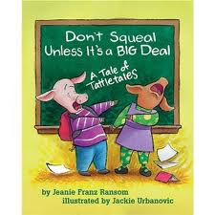  The Worst Day of My Life by Julia Cook  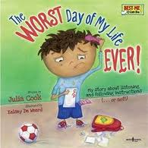 | Worry Wall  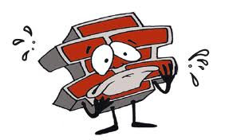  Glass Man (overreacts to a problem) | *Feeling thermometer  *Size of the problem  *Zones of regulation  * MY mood monitor
Social  Fake | This is a concept that explores how “genuinely” interested we feel as we engage in a social dialogue with others. Most of us are interested in getting to know one another, even though we aren’t always fascinated by exactly what they say. We teach that often we simply tolerate other’s conversational topic in order to maintain the social-emotional connection. How we make each other feel is more important than the exact words used to sustain the relationship. | “I have one student who sabotages his inquiry group. Someone comes up with a decent (but not perfect) idea and most of the group goes along. However, one student can’t get past his idea being better and continues to call the idea ‘stupid.’”  or  “Joe brought birthday treats today and one student rudely shared ‘Ugh…I hate this kind of cookie.’” | You Get What You Get by Julie Gassman  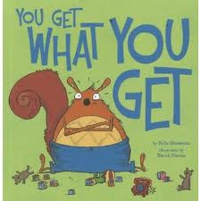  The Grouchy Ladybug by Eric Carle  Grumpy Gloria by Dewdney  First Grade, Here I Come! By Nancy Carlson  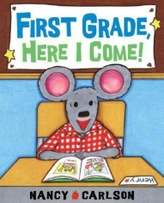  Diary of a Wimpy Kid by Jeff Kinney  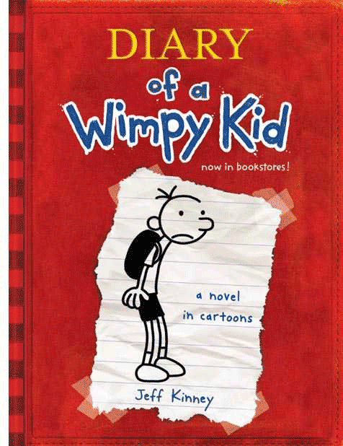 | Grump Grumpaniny | *Faking it when you are not Interested.  *Group work, group rules.
Whopping Topic  Change | When someone cannot figure out how one comment relates to something else that was just said | “Every time I start a lesson, Tom raises his hand and asks about snack…or lunch…or recess…etc.” | My Mouth is a Volcano by Julia Cook | Topic Twister | *Ways of talking that people DO NOT appreciate.
Thinking of You/  Just Me Kid | Defines the difference between cooperating in a group versus just focusing on one’s own needs | “I don’t like the topic the group picked for our power point, so I’m going to just sit here and not participate.” | Fancy Nancy by Jane O’Connor  How to Lose all Your Friends by Nancy Carlson  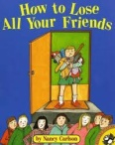 | One-Sided Sid | *Doing things as a group.
TT  (Tangent Talk) | Continuing to talk about the same topic even after people become disinterested | At recess a group of boys are talking about the new Spider Man movie and Johnny continues to give every detail and quote from the movie after others have moved on to a new topic. He has not noticed that they are no longer interested in what he is saying. | Alexander and the Terrible, Horrible, No Good Very Bad Day by Viorst  If you Take a Mouse to School by Numeroff  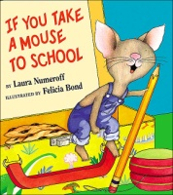  Lacey Walker, Nonstop Talker by Christianne Jones  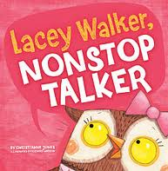  Miss Nelson is Missing by H. Allard  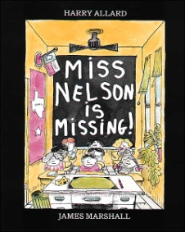 | Rock Brain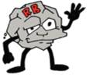 | *Being part of a group  *Which way are we speaking, tangent or topic?

